NESARE FNE14-798-27806
High Tunnel Bed & Trellised Crops Sprayer
Andy Fellenz
Fellenz Family Farm, Phelps NY
andy@fellenzfamilyfarm.com

Construction Summary

The pictures show our test mule. It is a little rough, crude and a lot ugly, but it got the job done. <20 minutes start to finish (from making up tank mix to final clean out rinse) to spray a 30X96 tunnel of trellised tomatoes uniformly and following label rates. This compares to greater than 1 hour when we used a SOLO hand pumped backpack sprayer.

Construction is simple and reflects a desire to have something that is easily modifiable as testing proceeded. The frame is welded together from 1X1X1/8wall square steel tubing. All of the parts – pump, battery, switches, control solenoids, plumbing fittings are standard and readily available. All of the nozzles and tips are TeeJet.

We tried to make the sprayer as small as possible to facilitate it’s use in high tunnels where the aisles are often narrow and there isn’t much room at the ends of the rows to turn a machine around to go down the next row. It’s overall width is ~1’ and length is ~2’ not including the handle.

We selected a tank with as large an opening as possible to facilitate clean-up. The whole tank can be scrubbed from the top and with the screen filter on the bottom, debris is caught before entering the pump. The two solenoids facilitate sprayer control on the boom, enabling easy selection of which side(s) are being sprayed and turning the nozzles off while turning the sprayer around at the end of the row, or when it isn’t needed, but still having the pump running to help with tank agitation.

Front view
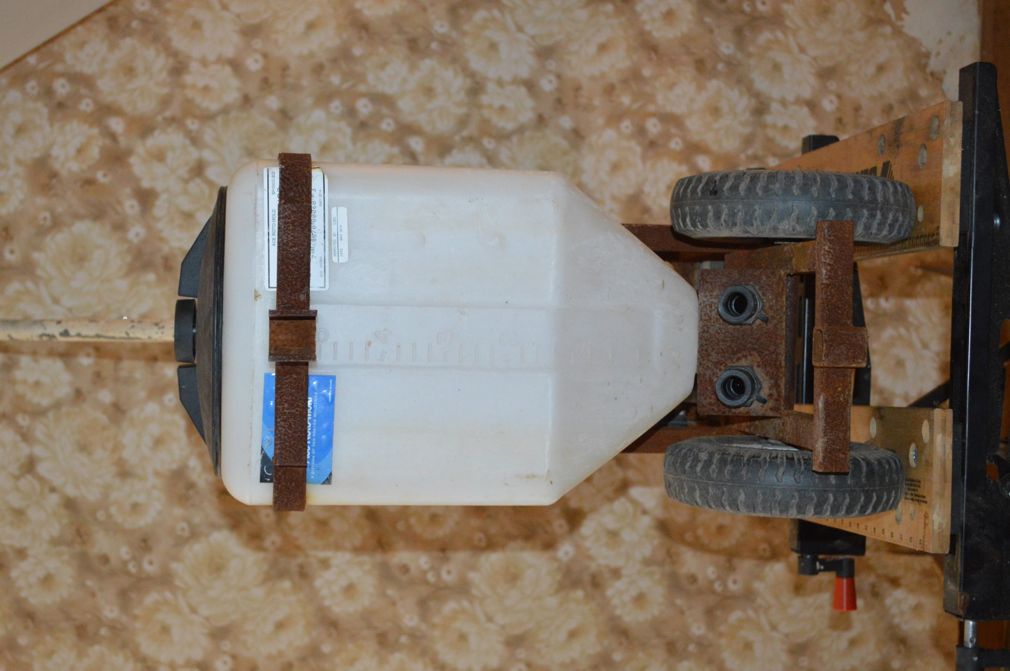

Right side view
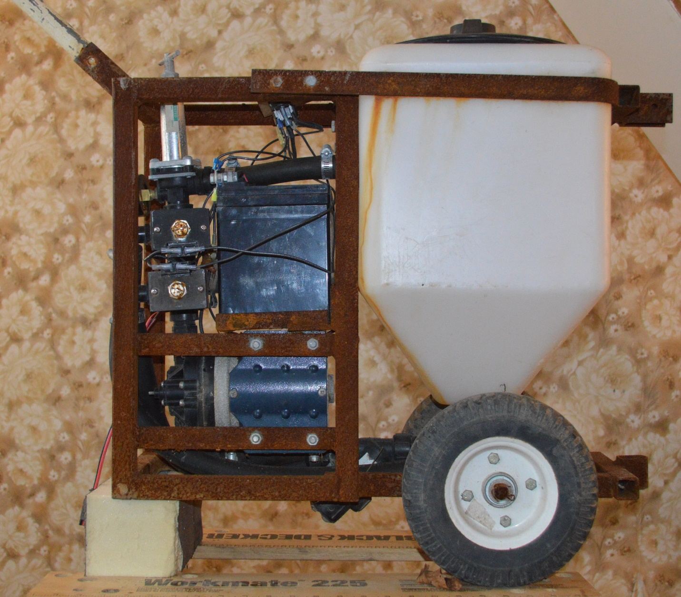

The right side view highlights both how compact the component layout is while also being set up for ease of maintenance and easy change out of components. The sprayer frame is all welded construction with the exception of the tank strap, which is bolted in place.
Rear view
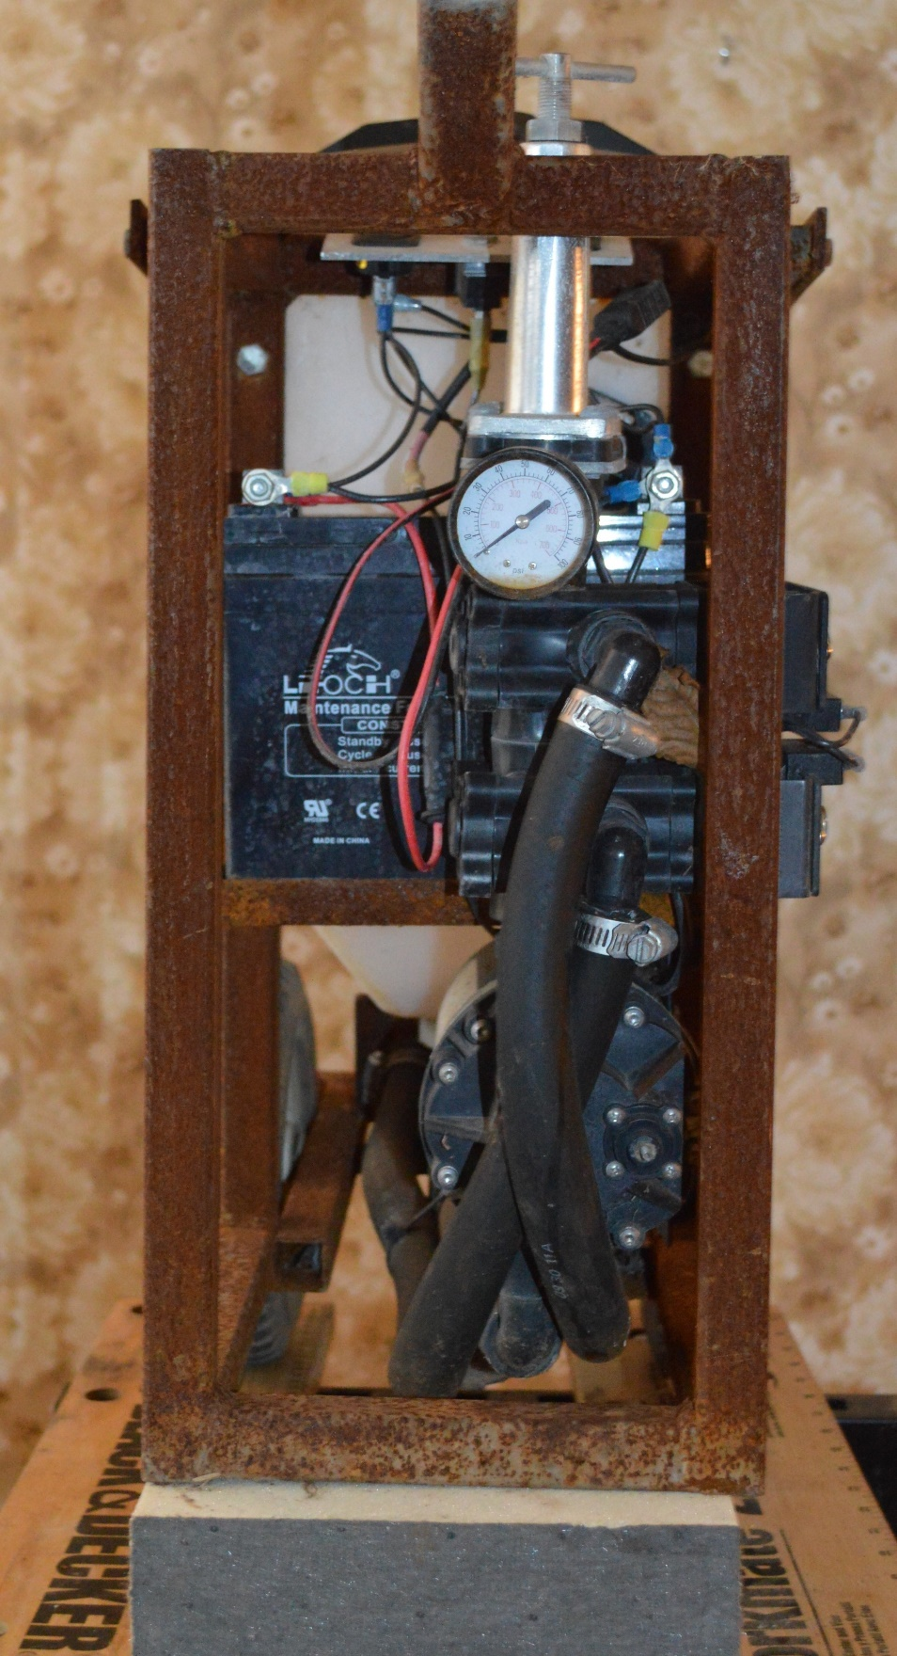

Left Side View
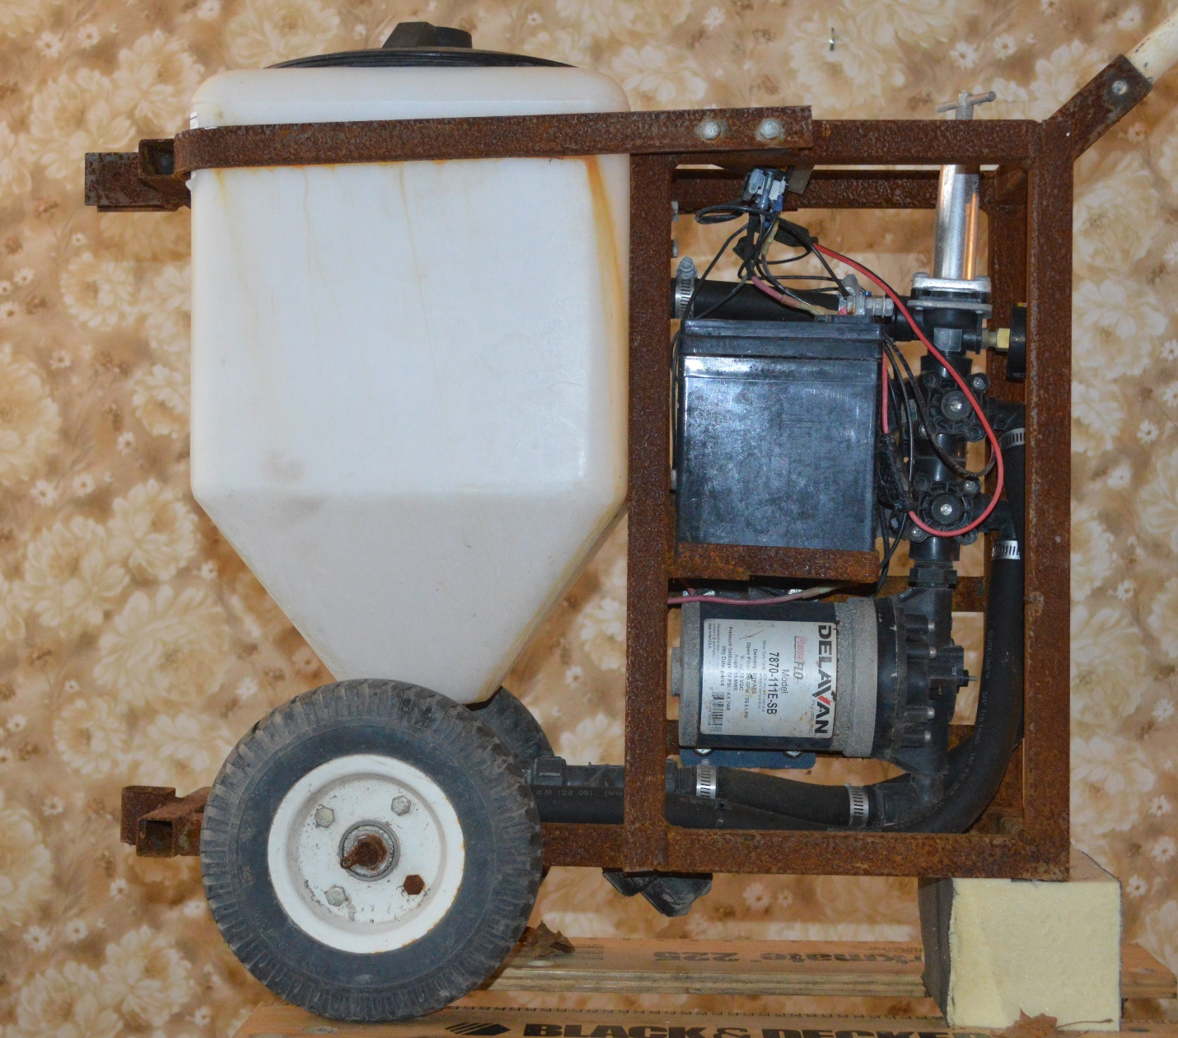
From this view, you can see how the sprayer is plumbed – the suction line from the bottom goes through a Y-filter, which if the screen is left in place, will catch solids before they go through the pump. The pump goes straight to the solenoid valves which direct flow to the boom. Above the solenoids is a pressure regulator which sets system pressure to the nozzles and dumps all overflow back to the tank. A pressure gauge is mounted on the regulator so that the operator can verify the system pressure. ¾” EPDM spray lines are used through-out.

Bottom View

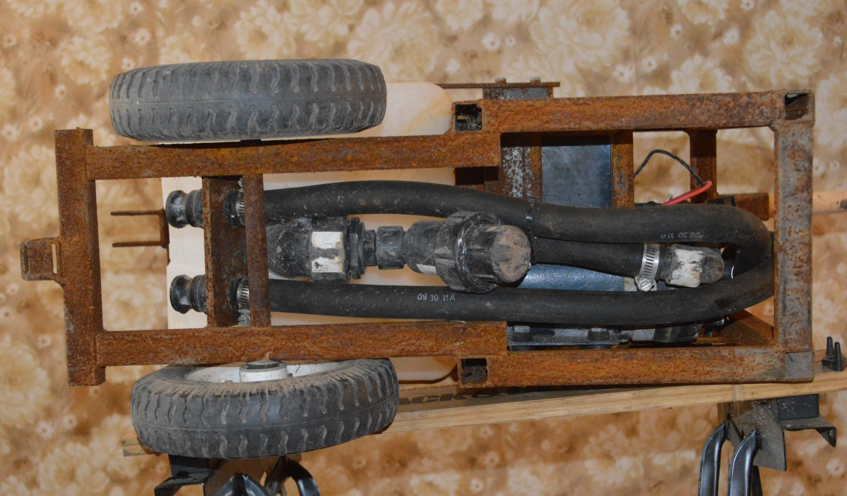
From the bottom, you can see how easy it would be to access the Y-filter and pull the screen to clean it. The cam action couplers for the boom are right at the front of the sprayer and very easy to access when changing the boom over.

Top View
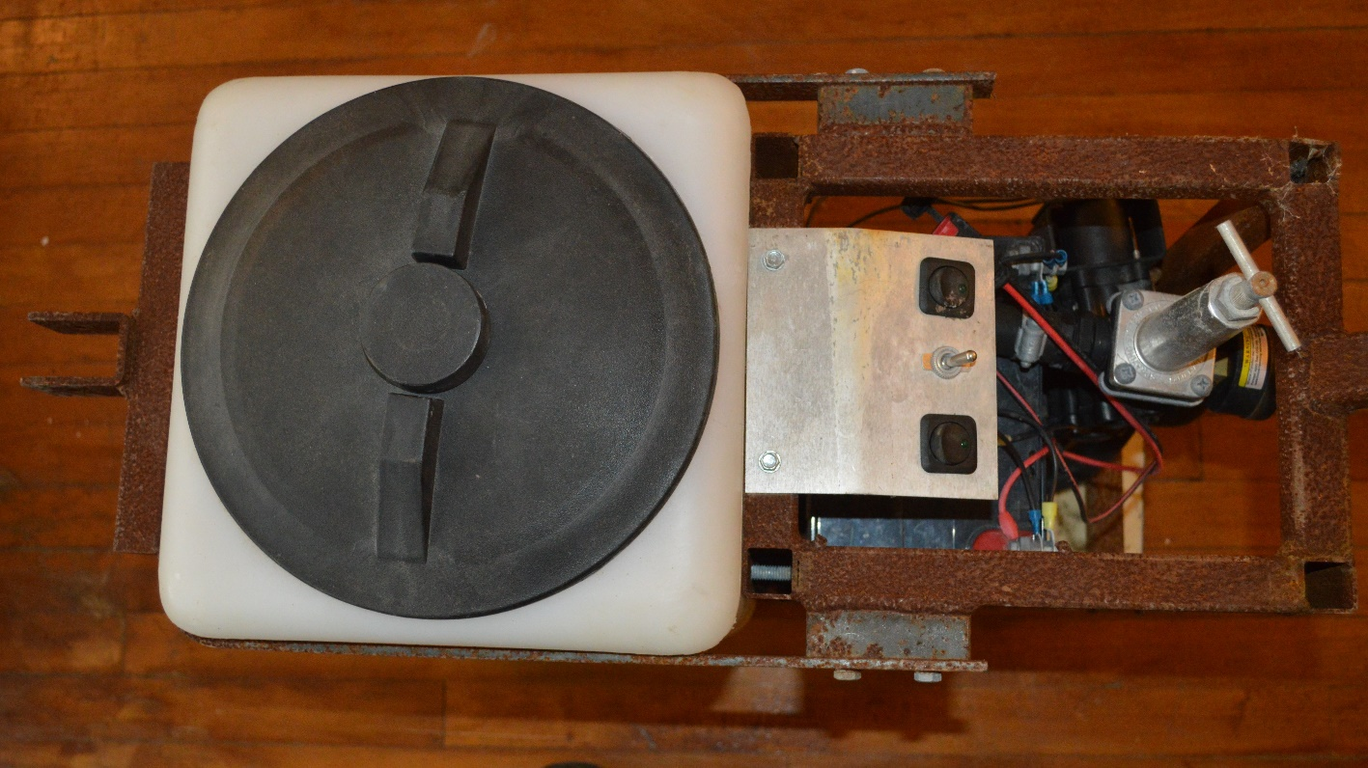
The controls are temporarily mounted on the panel behind the tank. The next iteration of the sprayer will see these controls move to the handle of the sprayer. The two black toggle switches control the solenoid valves which turn on spray to each side of the boom. The center switch turns on the pump. We need to add a battery kill switch which will turn off power to this panel. As it is set up now, the pump can be turned off with the solenoids turned on, which runs the battery down.
The pressure regulator allows for setting pressure to the spray tips. Depending upon the material being sprayed and tips being used this can be a very helpful feature, especially for ensuring that material is being sprayed at label rates.
Vertical Boom
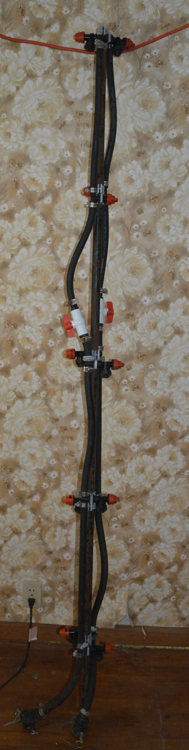 The vertical boom was set up with 10 nozzles, 18” apart. It is 84” tall and provides full coverage of the plant canopy. TeeJet QJ300 series nozzle bodies were used on the boom. It is easy to change tips on these nozzle bodies and they are relatively inexpensive. Cam action couplers are used to connect the spray lines to the sprayer. ¼ turn ball valves allow the upper nozzles to be turned off easily if a crop with a relatively low canopy height is being sprayed.

Horizontal Boom

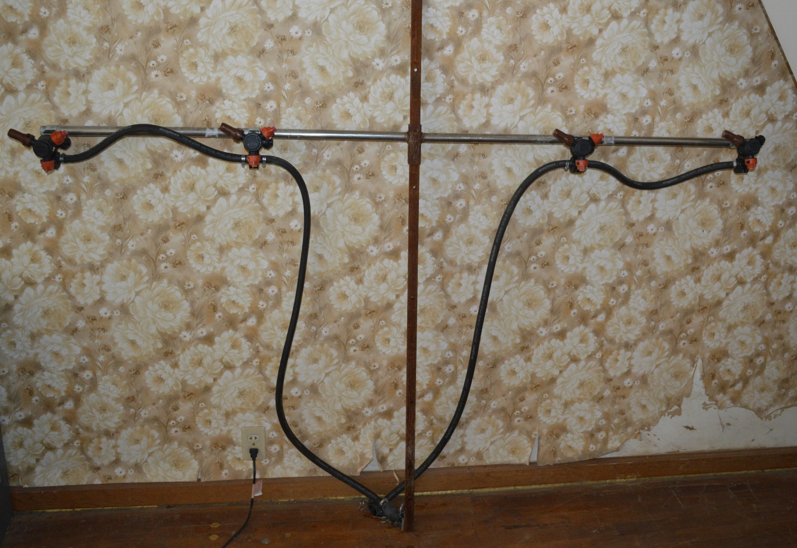

We selected QJ360 TeeJet 3 position nozzles on the horizontal boom to allow for easy switching between fertilizer tips and two size spray nozzles to enable guick materials changes.
The vertical portion of the boom has holes every 12” to allow for easy adjustment of the boom height depending upon the crop being sprayed. This size boom works well with 30-48” wide beds. If needed, a wider boom with additional nozzles could easily be fabricated.
Cam action couplers are used to connect the spray lines to the sprayer. Using the cam action couplers simplifies changeover from the horizontal to vertical booms and also facilitates clean-up of the boom as it is very easy to connect a hose to the lines and flush them.

